# When clicking the logo button the site brings up a 404 error page.

Done.

1. Can you remove the Red Bag with the Dollar sign

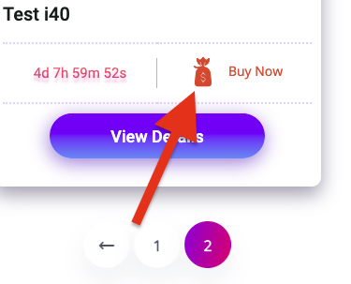

I changed the bag icon because I thought the change would be better than removing the icon.



1. When clicking into the advert the main image does not always default to the 1st image but to a random picture. Will you check this and make it default to the image 1

Done

1. Can you change “View Condition Report” to “Motorcheck Report”

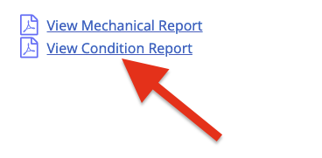

Done

1. Will you remove the Bid icon

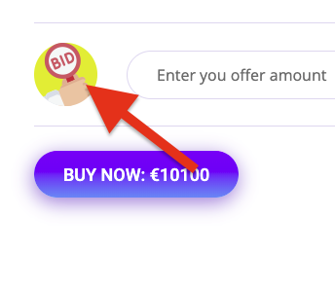

I also changed the icon.



6. Can you update the logo in the tab



C:\Users\Legend\Pictures\Screenshot_3.png

I can not use the logo for the favicon of this website because it does not show sharply in a tab. So I used other icon. Please send me if you have your own logo for favicon.

7. Can we add a section for “Body Grade” the admin will add a grade when listing the car. Also could you put a text box that the admin can add some comments on the car? 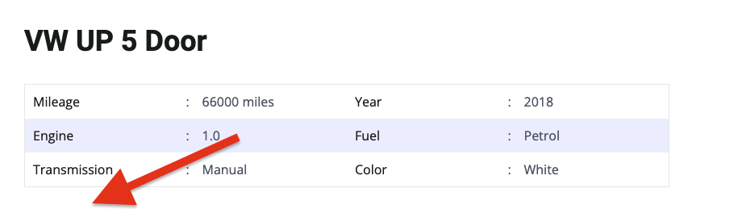

8. Can you remove the reviews

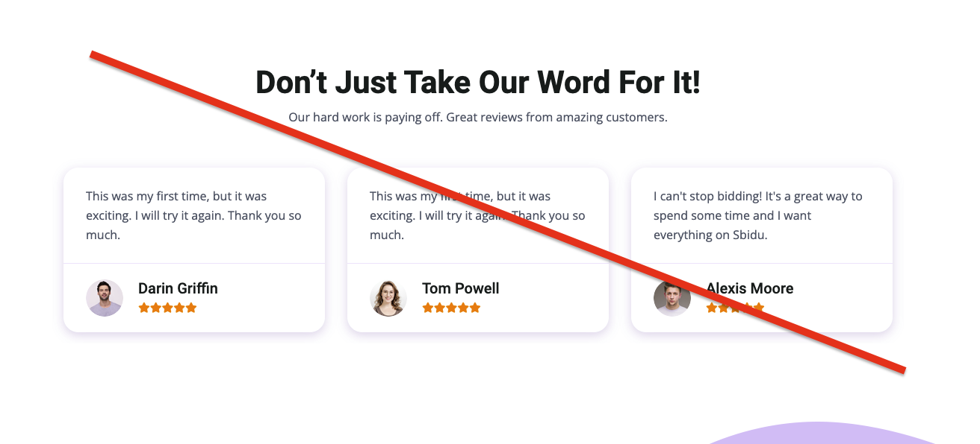

Done

9. Is there a way of the admin extending the timer without removing and uploading the listing as past offers will be deleted?

**Text Updates: (Done)**

****

**AG Trade centre allows motordealers to replenish stock on demand.**

**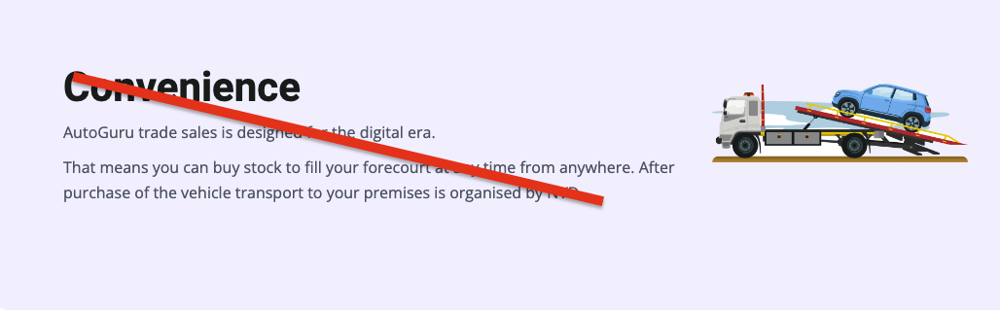**

Can we remove the “Convenience” test and add the below

**Buy with confidence**

All our cars come with an assessment report allowing you to budget for any repairs prior to retailing

**Buying options to suit you**

Buy a vehicle immediately with a simple click of the “Buy it now” button or place an offer with the highest realistic offer at the end of the timer winning the vehicle

**Delivery**

After vehicle payments have cleared delivery will be arranged to your business location.

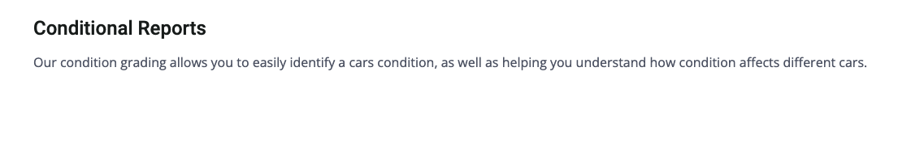

Under “Conditional Reports” on the listing can you add the below:

Grade 1

The vehicle may have minor interior and exterior defects i.e. minor scratches or dents and minor replacement parts could also be required.

Grade 2

The vehicle may require repairs as Grade 1 plus up to 1 major or minor bodyshop repair. The replacement of more significant internal or external trim parts (excluding panels) may also be required.

Grade 3

The vehicle may require repairs as Grade 1 & 2 plus may include up to 5 minor bodyshop repairs, 3 major bodyshop repairs or a combination of major and minor repairs. The vehicle may include a single replacement bumper.

Grade 4

The vehicle may require repairs as Grade 1, 2 & 3. It may have a combination of major and minor repairs and could include a non-structural replacement panel.